1. Databases

* Create RDS Instance
* RDS Backups, Multi-AZ, Read Replicas-Theory/Demo
* Dynamo DB
* RedShift
* Elasticache

1. DNS-?

* Route-53
* Routing Policies

Simple Routing

Weighted Routing

Latency Based Routing

Failover Routing

Geolocation

1. Disaster Recovery

1) Databases

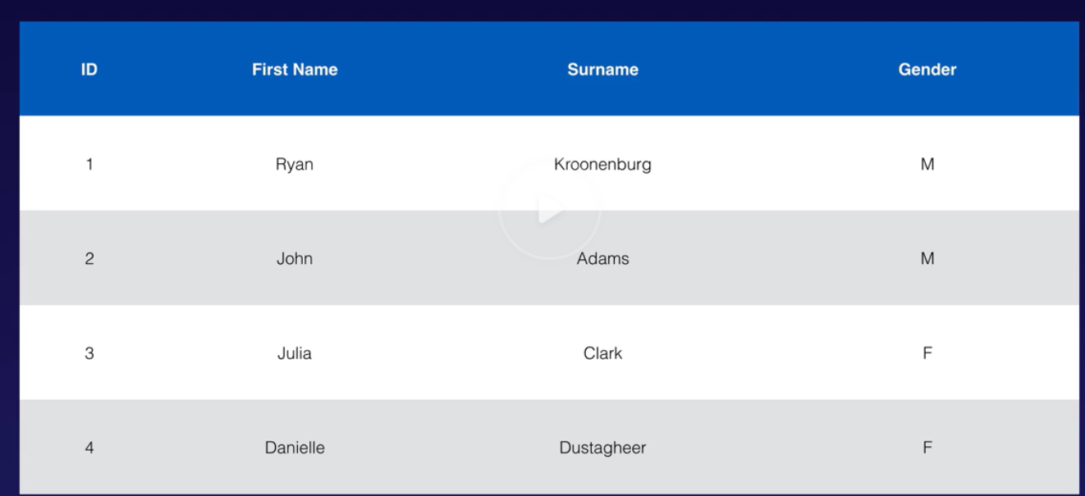

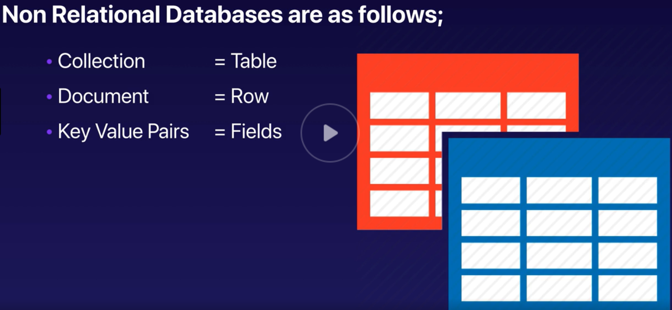

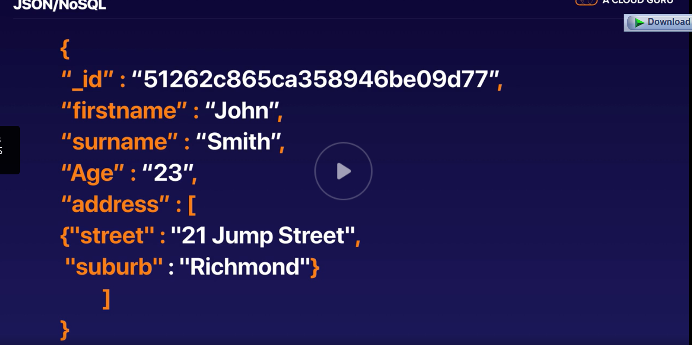

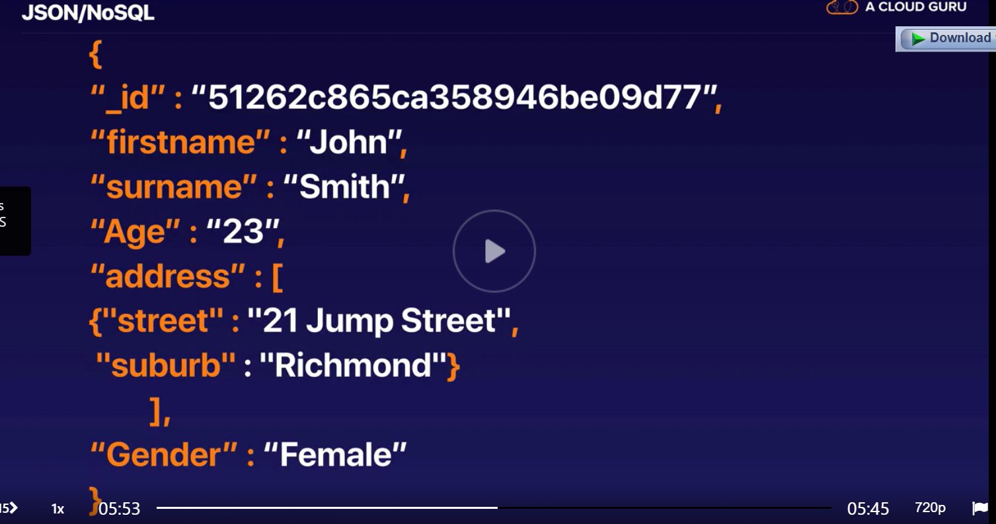

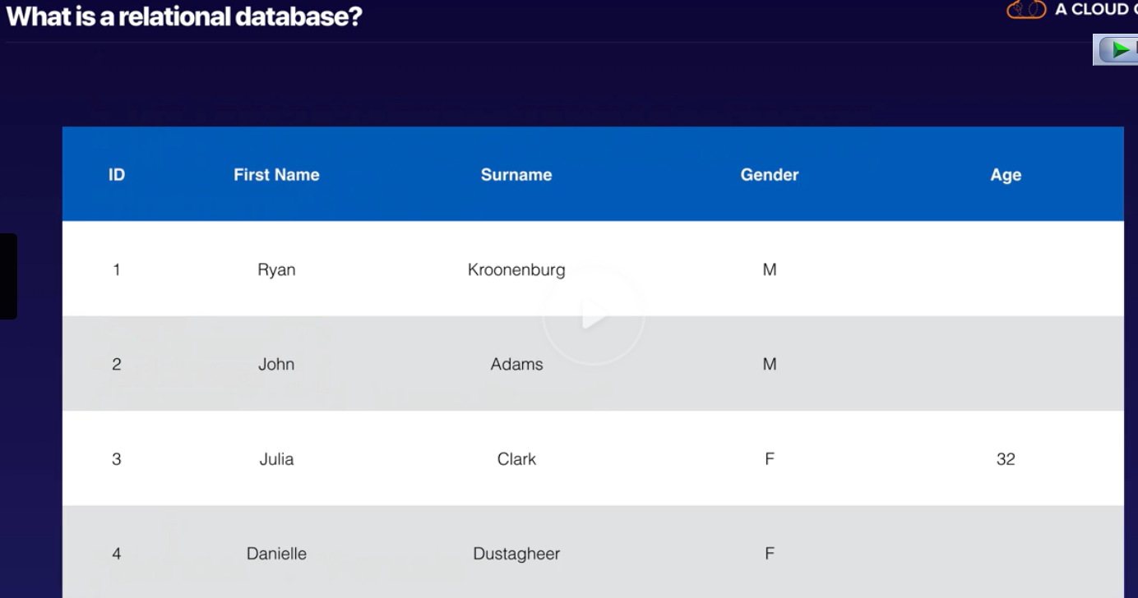

Create RDS Instance

How to test connectivity to DB?

nslookup **simplilearndb.crxpnvufsxnh.eu-west-1.rds.amazonaws.com**

**mysql -h simplilearndb.crxpnvufsxnh.eu-west-1.rds.amazonaws.com -P 3306 -u simplilearndb -p**

**Backup Database Backups**

Two different types of Backups:

**Automated Backups**

**Database Snapshots**

Automated Backups – recover database to any point in time within a specified ‘retention period’

**Retention period can be between 1 – 35 days**

Automated Backups – Takes a daily snapshot and also keep transcaction logs throughout the day

Recovery 🡪 AWS will choose the most recent daily backup and apply the the transaction logs for the day. Therefore **this will allow the Point in time recovery down to a second**.

Enabled by Default, Data Stored in S3, and free storage size equal to size of DB.

Backups taken within a defined Window, I/O suspended during this period, increase in latency

**Snapshots – done manually**, user initiated. Stored even after you delete the RDS instance

When you restore either of the Backup, the restored version of the DB will be a new RDS instance

Original.us-east-1a.rds.amazonaws.com 🡪 restored.us-east-1.rds.amazonaws.com

Multi-AZ

**Allows the exact copy of the Production Database in another Availabilty Zone**.

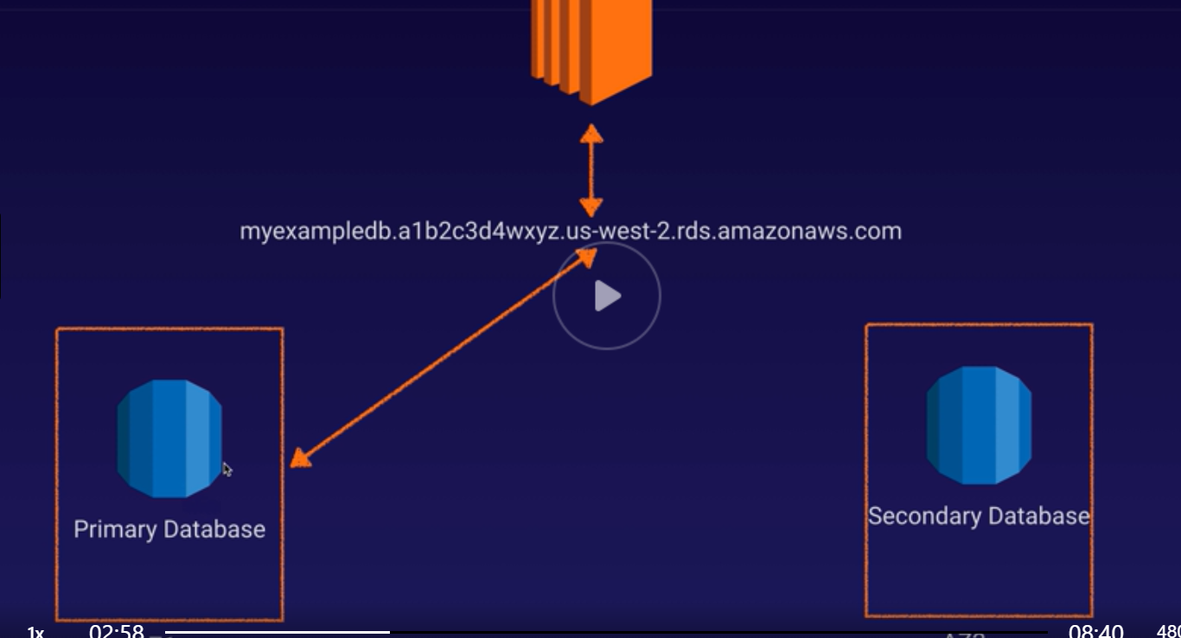

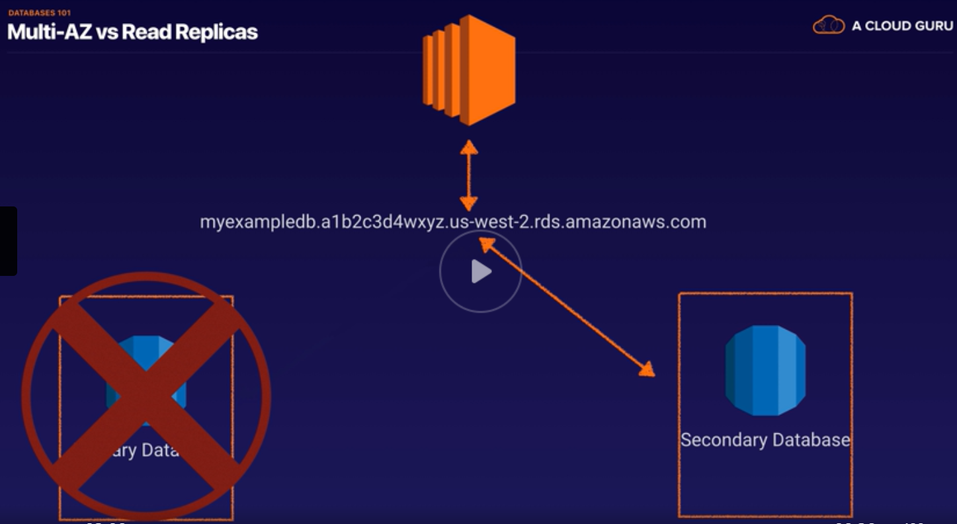

The writes to the Primary DB is automatically synched to a stand by DB

So in the event of a failure or planned maintenance **RDS will failover to Standby automatically**

For Disaster Recovery not to improve performance.

Available for SQL Server, Oracle, MySql Server, PostgreSQL, MariaDB

**Read Replicas**

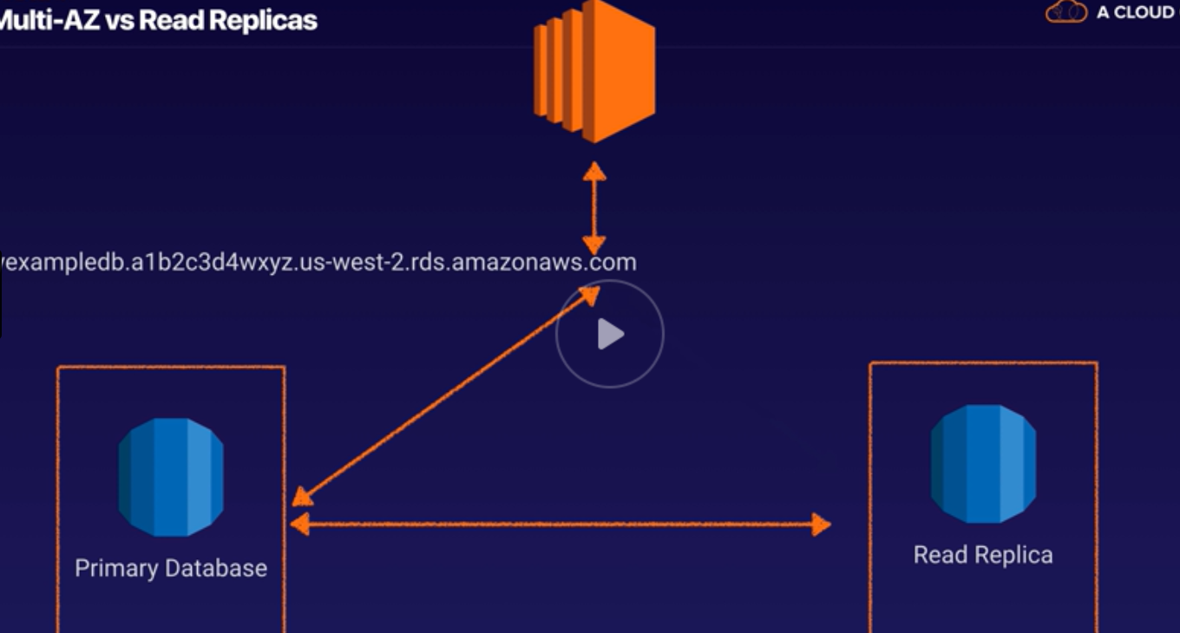

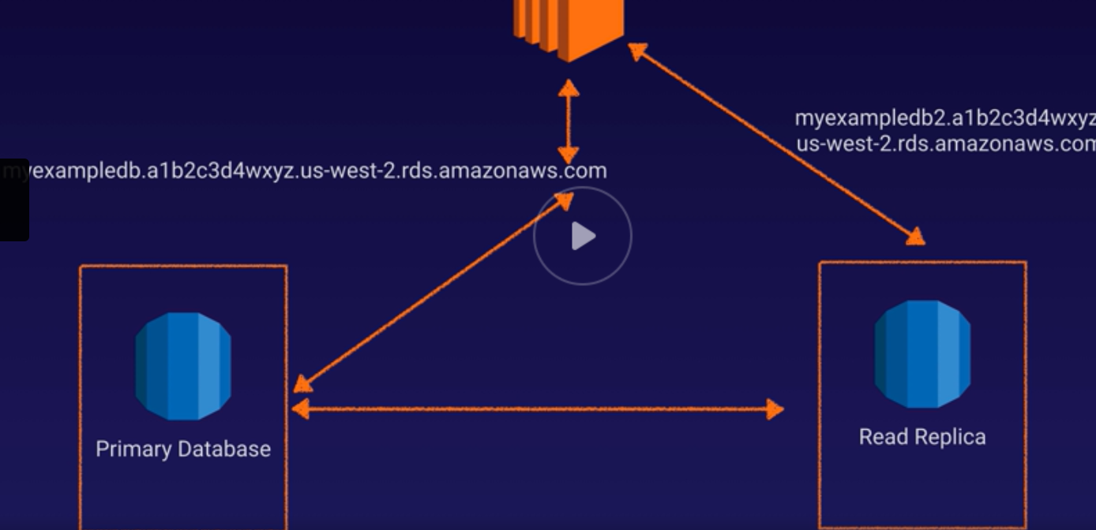

Allow you to have a read only copy of the Prod Database

Asynchronous Replication from Primary to Read Replicas, **useful for Read Heavy Databases**

Available for MySqlServer, PostGreSQL MariaDB, Aurora

**Key Points**

**Not used for DR**

**Must have Automatic Backups turned on to deploy Read Replicas**

**Can have up to 5 read replicas of any DB**

**Possible to have Read Replicas of Read Replicas-but latency high**

**Each Read Replicas have its on DNS Endpoint**

Possible to have read replicas that have Multi-AZ

**Read Replicas can be promoted to be their own Databases but it will break the replication**

**Can Read Replicas in a 2nd Region**

**Demo on Multi-Az, Read Replicas, and Backup turned on**

**Dynamo DB**

**Amazon Dynamo DB is fast flexible NoSql DB FOR APPS THAT require Minimum latency**

**Fully Managed, supports both Doc and key-value data models**

Stored on SSD

Spread across 3 geographically distinct data centres

**Eventual consistent reads**

Consistency across all copies of data in within seconds, A read after a short time returns updated data

**Strongly Consistent Reads**

**RedShift – fast and powerful, fully managed petabyte scale DW in the cloud**

**Elasticache**

**WebService that makes it easy to deploy, operate and scale in-memory cache in the cloud**

It helps to improve the performance of web applications

By allowing to retrieve information from fast, managed, in memory caches instead of using slower disk based databases

Supports **Memcached and Redis**

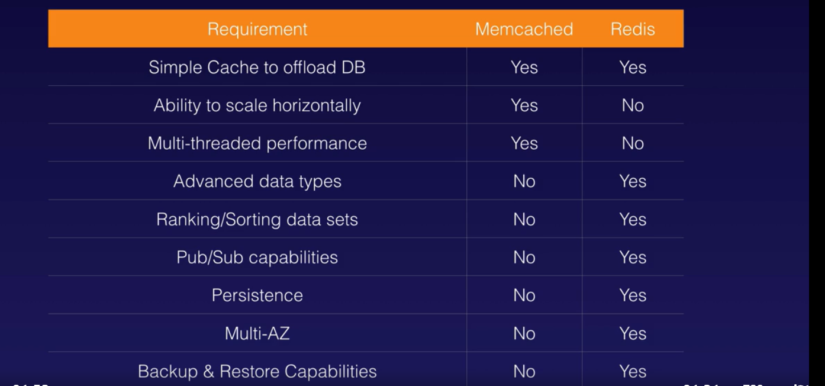

<https://docs.aws.amazon.com/AmazonRDS/latest/UserGuide/TUT_WebAppWithRDS.html>

DNS-Route 53


     Conceptual graphic that shows how the Domain Name System and RouteÂ 53 route internet traffic to the 
      resources for www.example.com.
    

Power Point- DNS

Hosted Zone

A **hosted zone** is a collection of resource record sets **hosted** by Amazon Route 53. Like a traditional DNS **zone** file, a **hosted zone** represents a collection of resource record sets that are managed together under a single domain name.

For Example a Hosted Zone🡪 [www.xyz.com](http://www.xyz.com)

[www.xyz.com--](http://www.xyz.com--)> 192.168.4.2

For example, the hosted zone for example.com might include a record that has information about routing traffic for www.example.com to a web server that has the IP address 192.0.2.243, and a record that has information about routing email for example.com to two email servers, mail1.example.com and mail2.example.com. Each email server also requires its own record.

Type of Record Sets

A -🡪 Returns a 32-bit [IPv4](https://en.wikipedia.org/wiki/IPv4) address, most commonly used to map [hostnames](https://en.wikipedia.org/wiki/Hostname) to an IP address of the host

AAAA🡪 Returns a 128-bit [IPv6](https://en.wikipedia.org/wiki/IPv6) address, most commonly used to map [hostnames](https://en.wikipedia.org/wiki/Hostname) to an IP address of the host.

CNAME -🡪 Alias of one name to another: the DNS lookup will continue by retrying the lookup with the new name.

**Example – CNAME to record within the same domain:**

|  |  |  |  |
| --- | --- | --- | --- |
| **NAME** | **TTL** | **TYPE** | **DATA** |
| www.example.com. | 1800 | A | 192.168.1.2 |
| ftp.example.com. | 1800 | ALIAS | example.com |

Alias Record

**Amazon Route 53 alias records provide a Route 53–specific extension to DNS functionality**. **Alias records let you route traffic to selected AWS resources, such as CloudFront distributions and Amazon S3 buckets**. They also let you route traffic from one record in a hosted zone to another record.

Unlike a CNAME record, **you can create an alias record at the top node of a DNS namespace, also known as the zone apex**. For example, if you register the DNS name ABC.com, the zone apex is ABC.com. You can't create a CNAME record for ABC.com, but you can create an alias record for example.com that routes traffic to [www.example.com](http://www.example.com).

SOA- Record

OA record is a Start of Authority. Every domain must have a Start of Authority record at the cutover point where the domain is delegated from its parent domain. For example, if the domain mycompany.com is delegated to DNSimple [name servers](https://support.dnsimple.com/articles/dnsimple-nameservers/), we must include an SOA record for the name mycompany.com in our authoritative DNS records. We add this record automatically for every domain added to DNSimple. We show this record to you as a System Record on your domain’s Manage page.

Here’s a content example from an SOA record:

ns1.dnsimple.com admin.dnsimple.com 2013022001 86400 7200 604800 300

The SOA record includes the following details:

* The primary name server for the domain, which is ns1.dnsimple.com or the first name server in the vanity name server list.
* The responsible party for the domain: admin.dnsimple.com.
* A timestamp that changes whenever you update your domain.
* The number of seconds before the zone should be refreshed.
* The number of seconds before a failed refresh should be retried.
* The upper limit in seconds before a zone is considered no longer authoritative.
* The negative result TTL (for example, how long a resolver should consider a negative result for a subdomain to be valid before retrying).

NS – Record

## What is a NS record?

NS stands for ‘name server’ and this record indicates which [DNS](https://www.cloudflare.com/learning/dns/what-is-dns/) server is authoritative for that domain (which server contains the actual DNS records). A domain will often have multiple NS records which can indicate primary and backup name servers for that domain.

Example of an NS record:

|  |  |  |  |
| --- | --- | --- | --- |
| example.com | record type: | value: | TTL |
| @ | NS | ns1.exampleserver.com | 21600 |

Routing Policies

In Simple Routing Policy- You have one record with multiple IP Addresses, Route 53 returns the IP Addresses in a Random order

192.168.1.24

192.168.1.25

Route 53



[This Photo](http://commons.wikimedia.org/wiki/File:User_icon_2.svg) by Unknown Author is licensed under [CC BY-SA](https://creativecommons.org/licenses/by-sa/3.0/)

1. Weighted Routing

80%

20%

192.168.1.24

192.168.1.25

Route 53



[This Photo](http://commons.wikimedia.org/wiki/File:User_icon_2.svg) by Unknown Author is licensed under [CC BY-SA](https://creativecommons.org/licenses/by-sa/3.0/)

Health Checks:

1. You can set HealthChecks on Individual A Records
2. If it fails the record is removed until resolved
3. Can set SNS to notify if there is a failure

Latency Based Routing

Based on which region gives the best response time

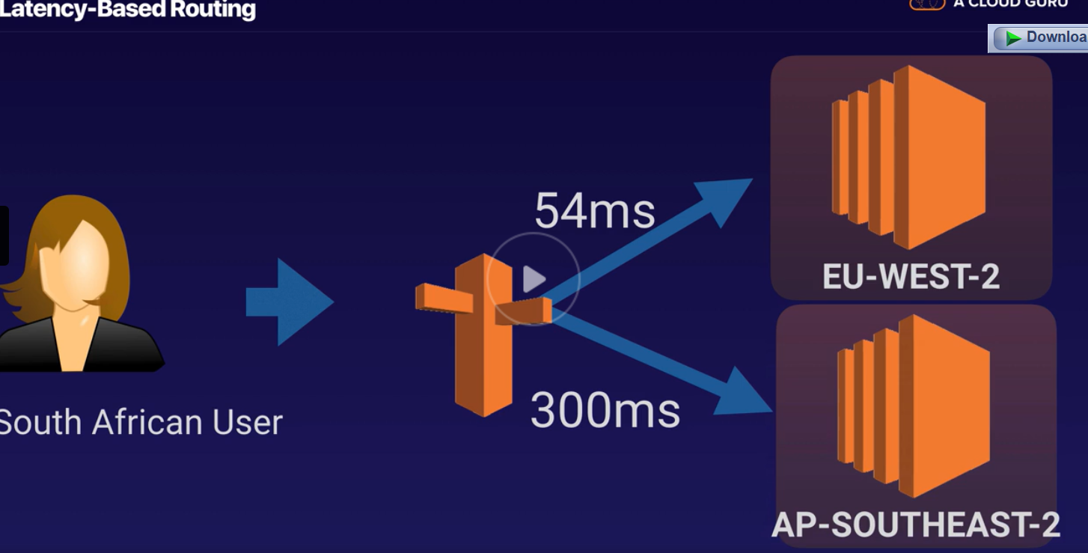

Failover Routing Policy

Used in a Active-Passive mode, you have primary site and secondary site. When one fails users will be routed to secondary node

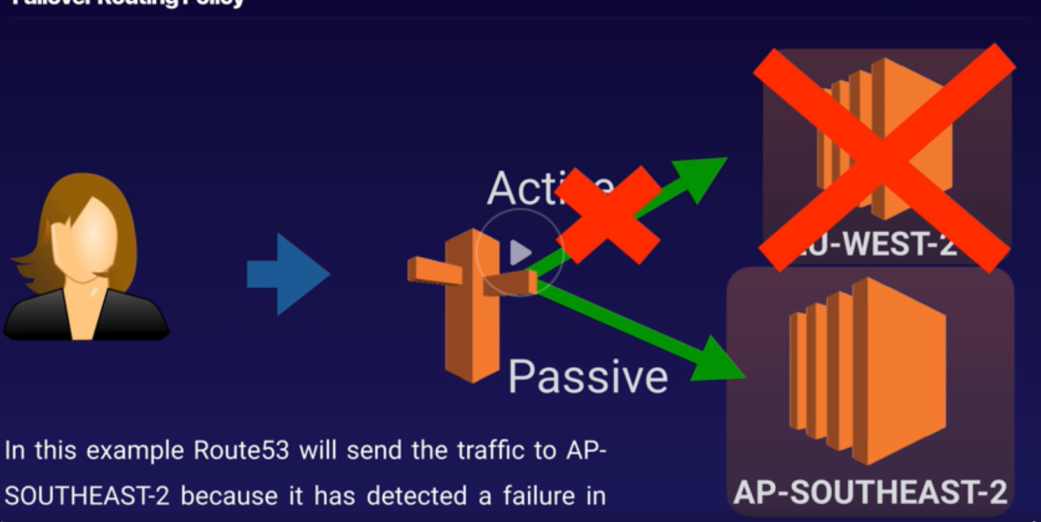

Geolocation Routing Policy- Routing Based on Geographical Location of the Users, for example you might want all users in India to be routed to the site in Mumbai.

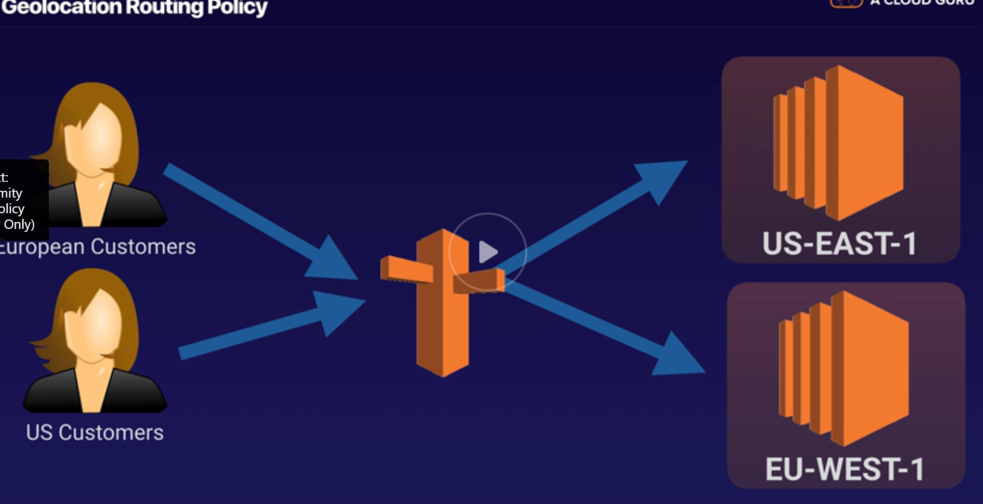

MultiValue Answer Policy

Same as Simple Routing but allows for putting health checks on a Route and allows you to associate to health Checks.

1. Latency Based Routing
2. Failover Routing
3. Geolocation